An open letter to the official website of Ennio Morricone
（See here in the original）

- Why publish an open letter?

  - Ennio Morricone Official website（Hereinafter referred to as the EMOW）It should be a formal website that authorized by Morricone, have legal status, be responsible for dealing with public affairs on the Internet for Morricone, and also is Morricone fans must face the website. For a long time, I'm in trust, respect and admiration of mood with him, continuous attention to him for more than 10 years, also gained a lot of knowledge. But as time goes on, I gradually discovered many problems and even mistakes in EMOW. In order to get help and solve these problems, I contacted him for 8 years by e-mail，but never get any reply from it. (See this page for more details) Out of respect and affection for the maestro of Ennio Morricone, also out of expectations to the EMOW improvement work, as a fan from china, after a long time of consideration, i think this is probably my only way I can contribute a little more power for this purpose.

1-2 I'm a loyal fan of Morricone, is also rooted in China's webmaster of "Morricone Fans" website If calculated from 1979 I start know Ennio Morricone, I have been following the maestro for nearly 40 years. I'm 80 years old this year. The maestro is 9 years senior to me, I think his physique is much better than mine. But we all belongs to the elderly, the natural law of life will be experienced more firsthand. I sincerely wish the maestro longevity and health, but I also hope that in the limited time of the maestro's healthy life, through his attention, examine and approve, collate and publish an exact and complete filmography for the world at EMOW. It should stand the test of history, don't leave many unsolved mysteries to posterity. In a sense, this is more important than holding a few concerts. Because there are many problems with the EMOW's filmography, and they have long ignored for the problem. Going on like this will cause irreparable damage! I hope to make an appeal through this open letter, ask questions, discuss, and make clear about right and wrong. Hope that there will be more force to promote and settlement of these problems at an early date. To simplify the length of the open letter, all questions have been published in feature articles for detailed study.

==========================================
2. 4 problems that need to be solved (sorted by importance)
These problems include:
1. Existing filmography (Film Music) problems in EMOW
2. A lot of missing works on the EMOW
3. The serious mistake of Morricone tour concert brochures
4. EMOW's problems in dealing with public relations
===========================================
2-1 Existing filmography (Film Music) problems in EMOW ( Only for "Film Music" or "Filmography"， exclusive of absolute music ）
There are some obvious mistakes in EMOW's “Film Music” (Filmography), a small number of possible infringement problems, there are 4 works urgently needed to be solved:

2-1-1 1961 short film "Verrò (short film) ". The exact data show that its composer is Matteo Marletta， the lyric author is Paolina Morrione, instead of the works of Ennio Morricone
Unless EMOW has sufficient evidence to show that this Paolina Morrione is Ennio Morricone, Otherwise, this will involve infringement problems, and have to pay attention to. (See here for detail）

2-1-2 1961 short film "Vicino al ciel (short film) ". All cases are the same as above

2-1-3 1961 TV “Alla scoperta dell'America". The publication of this work is displayed for 1961 at EMOW，There has been a long dispute over this. Now, there is definite evidence to show that it should be 1971. See here for detail

2-1-4 1999 film “Morte di una ragazza per bene-(TV Luigi Perelli) ”. This is a controversial film，because there is no any information about Ennio Morricone in the credits screenshot in the film. And in IMDB, CHIMAI's data，it also has nothing to do with Morricone. Why did the filmography of EMOW include it for a long time? A clear explanation (or cancellation) is needed See here example 24 for detail
---------------------------------
2-2. A lot of missing works on the EMOW
To clarify the laws of the filmography (existing 427 films) in EMOW, I carefully examined most of the films in my 370 existing films. In order to facilitate comparison and research, I divide them into 8 types according to the weight of Morricone's works ( A1, A2, B, C1, C2，D, E, F ). Then compare carefully with all the films I have, i think that at least 28 films should be added to the filmography of EMOW first (if including E and F types, a total of 50 films) See here for detail

The following is all general list（The number in parentheses is third version of chronology in the site）

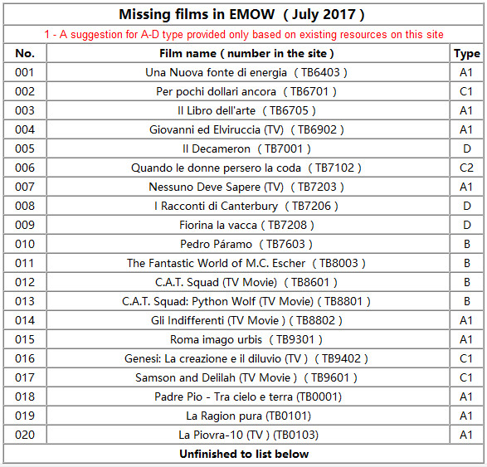

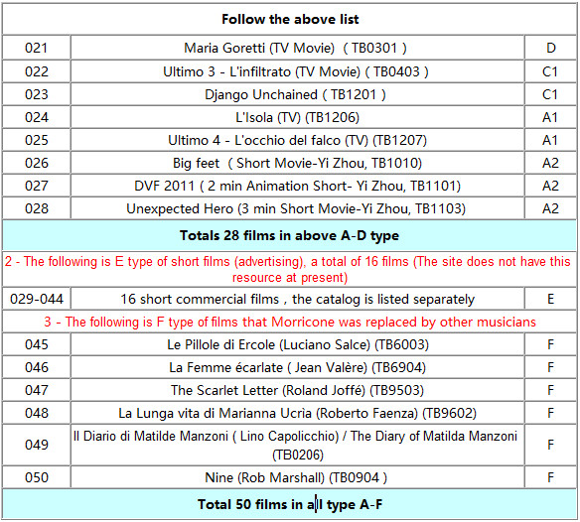

The above list is only an analysis and judgment from my existing film resources. I think they're just part of the missing films in EMOW. EMOW should have more films composed by Ennio Morricone, I hope they will re-examine and define them in accordance with the unified standards. In the preparation of the new filmography, it is very important to solicit opinions from some important websites and senior fans around the world. Example the complete filmography published by CHIMAI, the filmography published by IMDB, the book "Ennio Morricone Filmografie" (1961-2012, total 3 books) published by German in 2013 (See here and here) etc.，there are very rich and reliable data there. Not a few senior fans have been painstaking researching for years for the works from Ennio morricone, they have a high prestige and influence in the minds of fans all over the world. For example, I know that Belgium Didier Thunus, Austria Michael Caletka, French Patrick Bouster, Holland Martin Van Wouw etc. It is important to listen to their opinions in a proper way. (if need, I can provide their contact information.)
============================================
2-3. The serious mistake of Morricone tour concert brochures See here for detail
============================================
2-4. EMOW's problems in dealing with public relations See here for detail
============================================
Ennio Morricone's official website is a important web site for fans, it should be a field that to be loved, trusted and respected by worldwide fans. Over the years, the website has done a lot of work, this should be affirmed. But it does have a lot of problems, the only purpose of publishing this open letter is to promote its work, maintain the due authority of the website and the distinguished image of the maestro Ennio Morricone. Above these opinions may not be entirely correct, please feel free to contact me if there is any not proper or mistake, I will take the responsibility and correct it immediately
I wish the beloved maestro Ennio Morricone a healthy and long life! Hope his official website will do his best to sort out his vast works, as soon as possible publish an correct and authoritative filmography, It should be shared by the world and later generations， and make outstanding contributions to this end!

The webmaster of "Morricone Fans” Wenguang Han July 23,2017 in China

My email: qilingren@163.com or qilingren@hotmail.com

（Please forgive my poor English, thank you！）

